ASP.NET Core 8.0 Web API

Exercise-1: Create a Web API with GET & POST

- Code:

using Microsoft.AspNetCore.Mvc;
using System.Collections.Generic;

namespace WebApiDemo.Controllers
{
[ApiController]
[Route("[controller]")]
public class ValuesController : ControllerBase
{
private static List<string> values = new() { "value1", "value2" };

[HttpGet]
public IEnumerable<string> Get() => values;

[HttpPost]
public IActionResult Post([FromBody] string value)
{
values.Add(value);
return Ok(values);
}
}
}

- Output:

//GET/Values
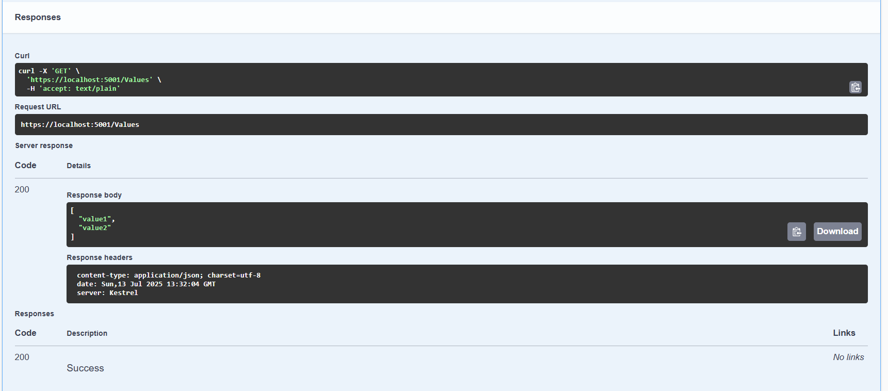

//POST/Values
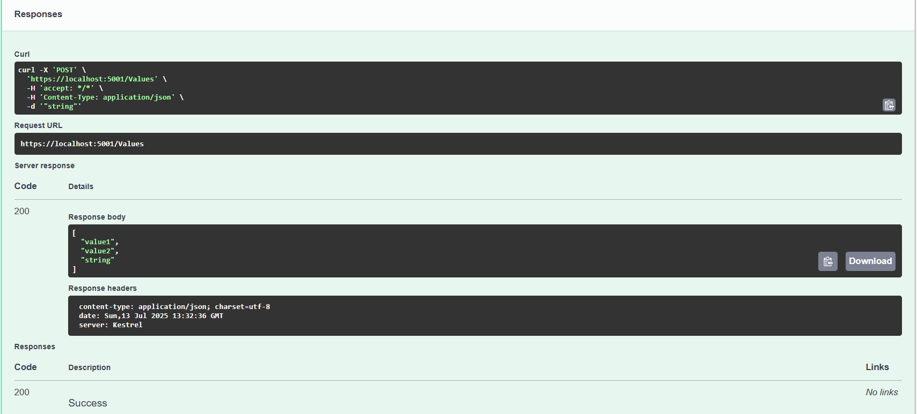

Exercise-2: Enable Swagger in Web API

- Code:

using Microsoft.AspNetCore.Authentication.JwtBearer;
using Microsoft.IdentityModel.Tokens;
using Microsoft.OpenApi.Models;
using System.Text;
using WebApiDemo.Filters;

var builder = WebApplication.CreateBuilder(args);

builder.Services.AddControllers();
builder.Services.AddEndpointsApiExplorer();

builder.Services.AddSwaggerGen(c =>
{
c.SwaggerDoc("v1", new OpenApiInfo { Title = "WebApiDemo", Version = "v1" });

c.AddSecurityDefinition("Bearer", new OpenApiSecurityScheme
{
Description = @"JWT Authorization header using the Bearer scheme.
Enter 'Bearer' followed by your token.
Example: Bearer eyJhbGciOiJIUzI1...",
Name = "Authorization",
In = ParameterLocation.Header,
Type = SecuritySchemeType.ApiKey,
Scheme = "Bearer"
});

c.AddSecurityRequirement(new OpenApiSecurityRequirement
{
{
new OpenApiSecurityScheme
{
Reference = new OpenApiReference
{
Type = ReferenceType.SecurityScheme,
Id = "Bearer"
},
Scheme = "oauth2",
Name = "Bearer",
In = ParameterLocation.Header,
},
new List<string>()
}
});
});

var key = Encoding.ASCII.GetBytes("mysuperdupersecret");
builder.Services.AddAuthentication(JwtBearerDefaults.AuthenticationScheme)
.AddJwtBearer(options =>
{
options.TokenValidationParameters = new TokenValidationParameters
{
ValidateIssuer = true,
ValidateAudience = true,
ValidateLifetime = true,
ValidateIssuerSigningKey = true,
ValidIssuer = "mySystem",
ValidAudience = "myUsers",
IssuerSigningKey = new SymmetricSecurityKey(key)
};
});

builder.Services.AddScoped<CustomAuthFilter>();

var app = builder.Build();

app.UseSwagger();
app.UseSwaggerUI();

app.UseHttpsRedirection();

app.UseAuthentication();
app.UseAuthorization();

app.MapControllers();

app.Run();

- Output:

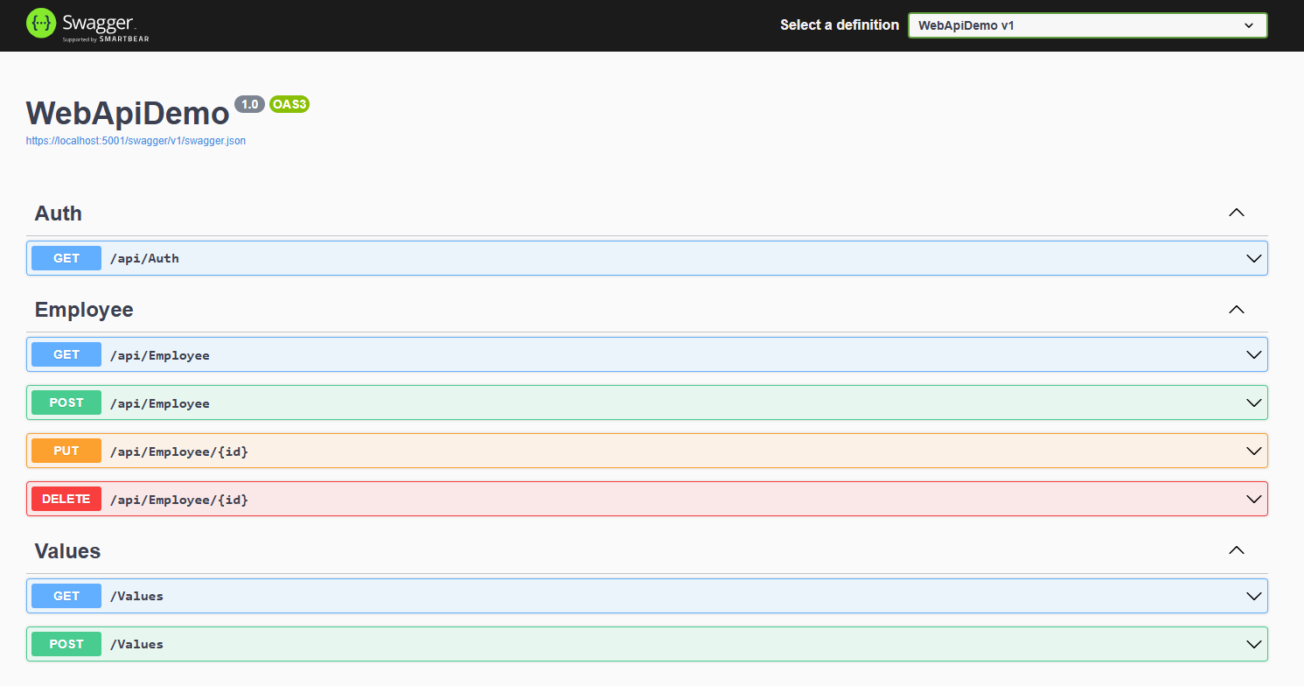

Exercise-3: Create Model & Custom Filter

- Code:

//Models/Employee.cs

using System;
using System.Collections.Generic;

namespace WebApiDemo.Models
{
public class Skill { public string SkillName { get; set; } }
public class Department { public string DeptName { get; set; } }

public class Employee
{
public int Id { get; set; }
public string Name { get; set; }
public int Salary { get; set; }
public bool Permanent { get; set; }
public Department Department { get; set; }
public List<Skill> Skills { get; set; }
public DateTime DateOfBirth { get; set; }
}
}

//Filters/CustomAuthFilter.cs

using Microsoft.AspNetCore.Mvc;
using Microsoft.AspNetCore.Mvc.Filters;

namespace WebApiDemo.Filters
{
public class CustomAuthFilter : ActionFilterAttribute
{
public override void OnActionExecuting(ActionExecutingContext context)
{
if (!context.HttpContext.Request.Headers.TryGetValue("Authorization", out var token) ||
!token.ToString().Contains("Bearer"))
{
context.Result = new BadRequestObjectResult("Invalid request - No Auth token or Bearer missing");
}
}
}
}

- Output:

//Unauthorize (Status Code: 401)
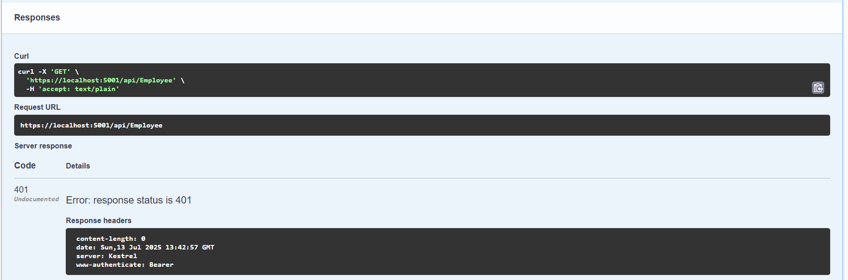

//Authorize (Status Code: 200)
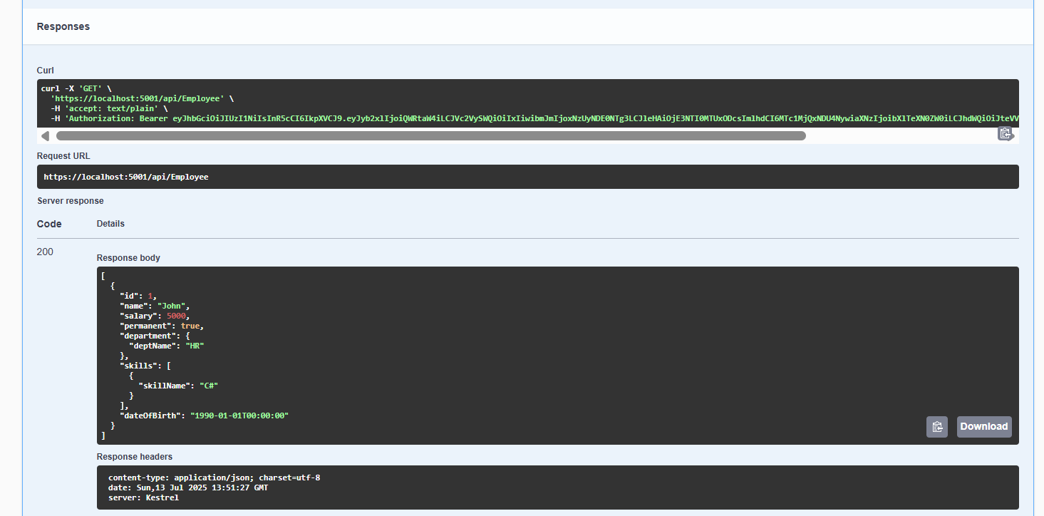

Exercise-4: Add PUT & DELETE for Employee API

- Code:

using Microsoft.AspNetCore.Mvc;
using Microsoft.AspNetCore.Authorization;
using WebApiDemo.Models;
using System.Collections.Generic;
using System.Linq;
using System;

namespace WebApiDemo.Controllers
{
[ApiController]
[Route("api/[controller]")]
[Authorize(Roles = "Admin")]
public class EmployeeController : ControllerBase
{
private static List<Employee> employees = new()
{
new Employee
{
Id = 1,
Name = "John",
Salary = 5000,
Permanent = true,
Department = new Department { DeptName = "HR" },
Skills = new List<Skill> { new Skill { SkillName = "C#" } },
DateOfBirth = new DateTime(1990, 1, 1)
}
};

[HttpGet]
public ActionResult<List<Employee>> Get() => employees;

[HttpPost]
public IActionResult Post([FromBody] Employee emp)
{
employees.Add(emp);
return Ok(emp);
}

[HttpPut("{id}")]
public IActionResult Put(int id, [FromBody] Employee emp)
{
if (id <= 0)
return BadRequest("Invalid employee id");

var existing = employees.FirstOrDefault(e => e.Id == id);
if (existing == null)
return BadRequest("Invalid employee id");

existing.Name = emp.Name;
return Ok(existing);
}

[HttpDelete("{id}")]
public IActionResult Delete(int id)
{
var existing = employees.FirstOrDefault(e => e.Id == id);
if (existing == null)
return NotFound();

employees.Remove(existing);
return NoContent();
}
}
}

- Output:

//PUT/api/Employee/{id}
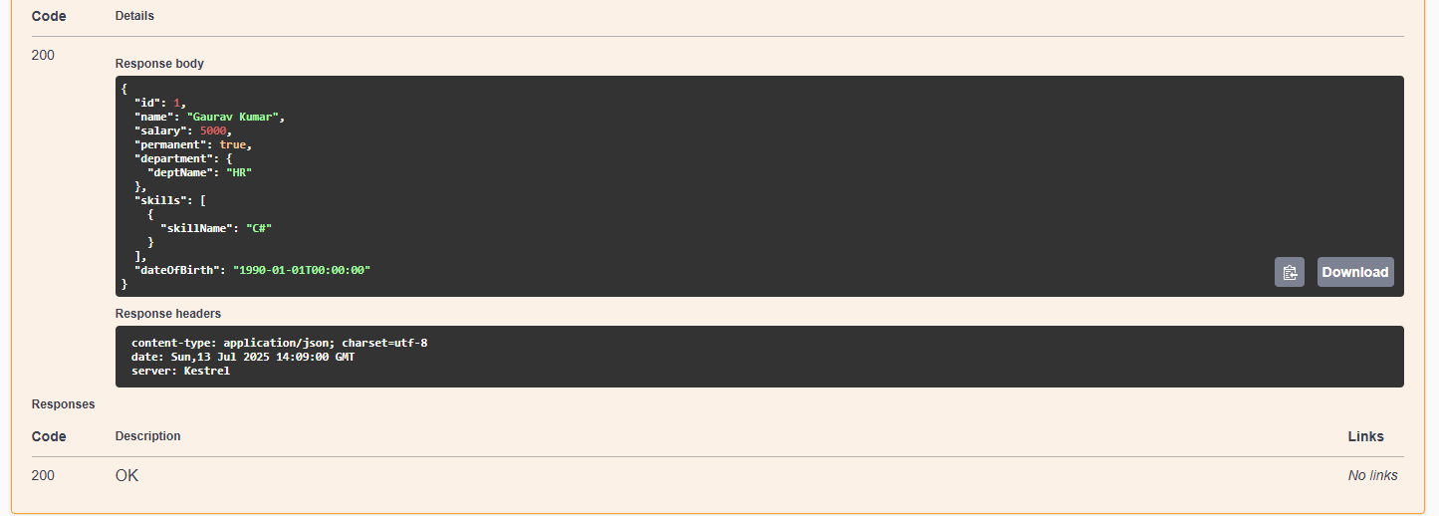

//DELETE/api/Employee/{id}
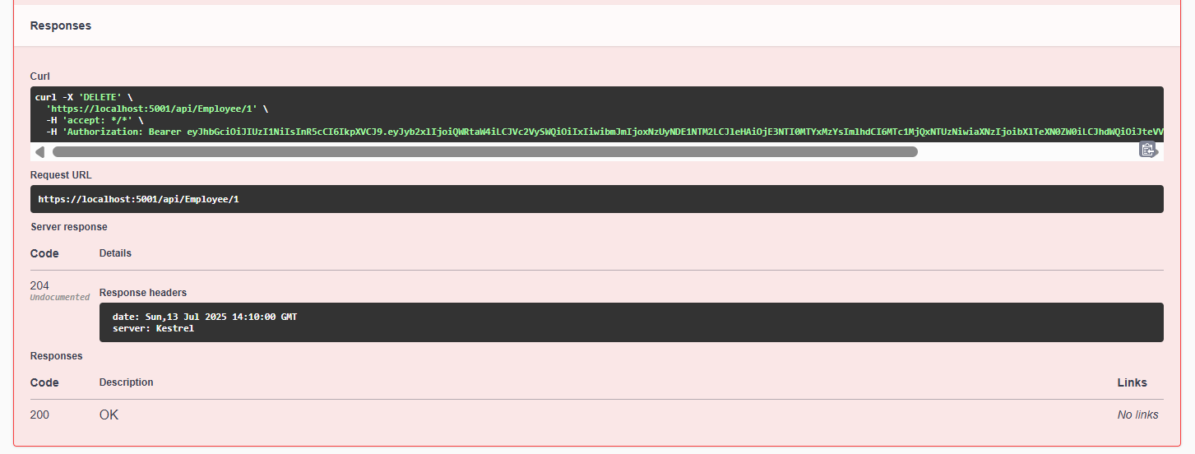

Exercise-5: Implement JWT Token Authentication

- Code:

using Microsoft.AspNetCore.Mvc;
using Microsoft.AspNetCore.Authorization;
using Microsoft.IdentityModel.Tokens;
using System.Text;
using System.IdentityModel.Tokens.Jwt;
using System.Security.Claims;
using System;

namespace WebApiDemo.Controllers
{
[ApiController]
[Route("api/[controller]")]
[AllowAnonymous]
public class AuthController : ControllerBase
{
[HttpGet]
public string GetToken()
{
var key = Encoding.ASCII.GetBytes("mysuperdupersecret");
var tokenHandler = new JwtSecurityTokenHandler();

var tokenDescriptor = new SecurityTokenDescriptor
{
Subject = new ClaimsIdentity(new[]
{
new Claim(ClaimTypes.Role, "Admin"),
new Claim("UserId", "1")
}),
Expires = DateTime.UtcNow.AddMinutes(10),
Issuer = "mySystem",
Audience = "myUsers",
SigningCredentials = new SigningCredentials(new SymmetricSecurityKey(key), SecurityAlgorithms.HmacSha256Signature)
};

var token = tokenHandler.CreateToken(tokenDescriptor);
return tokenHandler.WriteToken(token);
}
}
}

- Output:

//Token Generation
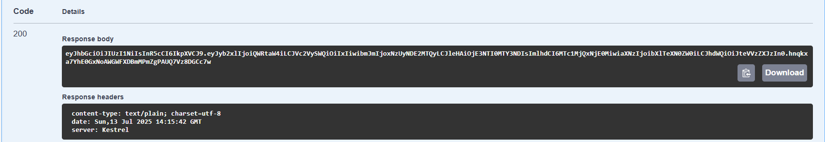

//Authorization
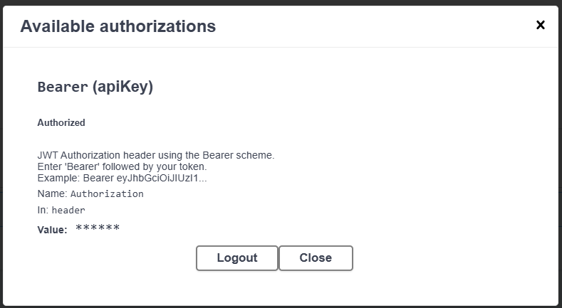

Exercise-6: Kafka Producer and Consumer

- Code:

//Kafka/KafkaProducer.cs

using Confluent.Kafka;
using System;
using System.Threading.Tasks;

namespace WebApiDemo.Kafka
{
public class KafkaProducer
{
public static async Task Produce(string topic, string message)
{
var config = new ProducerConfig { BootstrapServers = "localhost:9092" };

using var producer = new ProducerBuilder<Null, string>(config).Build();
var result = await producer.ProduceAsync(topic, new Message<Null, string> { Value = message });
Console.WriteLine($"Delivered to: {result.TopicPartitionOffset}");
}
}
}

//Kafka/KafkaConsumers.cs

using Confluent.Kafka;
using System;
using System.Threading;

namespace WebApiDemo.Kafka
{
public class KafkaConsumer
{
public static void Consume(string topic)
{
var config = new ConsumerConfig
{
BootstrapServers = "localhost:9092",
GroupId = "test-consumer-group",
AutoOffsetReset = AutoOffsetReset.Earliest
};

using var consumer = new ConsumerBuilder<Ignore, string>(config).Build();
consumer.Subscribe(topic);

CancellationTokenSource cts = new CancellationTokenSource();

try
{
while (true)
{
var cr = consumer.Consume(cts.Token);
Console.WriteLine($"Consumed message: {cr.Value}");
}
}
catch (OperationCanceledException)
{
consumer.Close();
}
}
}
}

- Output:

//Producer
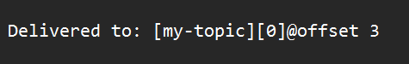

//Consumer
